Evaluation of CuNiFer 10 Biofouling Resistance
Mark Bushnell, CoastalObsTechServices LLC
July, 2018

Datawell (http://www.datawell.nl) is the manufacturer of the world’s most respected wave buoy. In 2012 Datawell celebrated a 50th anniversary, a measure of corporate stability nearly without peer in the oceanographic industry. Most Datawell wave buoys have AISI 316 stainless steel hulls, but Datawell offers an optional Cunifer 10 hull. Cunifer 10 is a copper / nickel / iron alloy with natural anti-corrosion and anti-biofouling properties, see http://www.columbiametals.com/products/copper-alloys/copper-nickel-9010
for further details. Approximately one third of Datawell buoys are sold with Cunifer 10 hulls to very satisfied repeat customers, but curiously the material is not widely used elsewhere in the oceanographic community. This note describes an informal test of the anti-biofouling properties of Cunifer 10.

A total of eight sample plates were deployed during the six month period 04/21/12 - 10/24/12, consisting of the following (Fig. 1, left to right):

1 2 3 4 5 6 7
Figure 1 - Initial deployment of a variety of panels used to investigate anti-biofoulant properties. For reference, the overall length of the PVC pipe is 1.5 meters
- An untreated aluminum control panel provided by Severn Marine Technologies LLC.
- An aluminum panel coated with ClearSignal, provided by Severn Marine Technologies LLC. See http://www.severnmarinetech.com.
- A 316 stainless steel plate covered with a layer of 10 mil PVC plumber tape, and topped with copper tape.
- The Datawell CuNiFer10 wave buoy hull sample.
- An untreated 316 stainless steel plate.
- A fiberglass plate with three coats of Pettit Trinidad SR, product 1677, containing 75% cuprous oxide. This paint is well known for its effectiveness but faces a potential ban because of the very high copper content.
- An aluminum control plate provided by Severn Marine Technologies LLC coated with ~ 0.5 mm Desitin (40% zinc oxide diaper rash paste). Anecdotal evidence suggests that Desitin prevents the formation of a bacterial layer necessary before barnacles and other hard-shell bio-foulants will settle on a surface. Desitin is a soft coating with the possibility of ablation during long-term deployments. There was also a question of interaction of the aluminum plate with zinc oxide, the primary ingredient of Desitin.
- An aluminum plate coated with AeroKret (not shown in this initial deployment photo, Figure 1). This coating is not an anti-foulant, the vendor claims that it is non-toxic to bio-organisms but any adhering bio-foulants should be easily cleaned/removed. See https://www.asm-usa.com/index.php/aerokret for coating properties and applications. This sample was provided after the start of the test, and was installed on day 22.

The plates were fastened to two parallel 1.5 meter PVC pipes with stainless steel screws. Nylon washers were used to isolate the screws from the plates (Figure 2). The PVC pipe provides a non-conductive framework, and when the screws were tightened in the pipe the compression provided a lock-tight fastening for these pan head screws.

Figure 2 - Nylon washers isolated the dissimilar metals of the stainless steel screws and the test plates
The test was conducted at Bay Point Marina in Norfolk, VA. Nearby marine and meteorological data during the test period can be obtained at http://tidesandcurrents.noaa.gov from the stations located at the Chesapeake Bay Bridge Tunnel (CBBT) and Cape Henry.

The plates were suspended vertically at a depth of about 2 feet (plate center), ensuring the availability of ambient light to promote algal growth. They were deployed on a floating dock so the depth remained constant. The plates were recovered, photographed, and redeployed once a week during the test period.

After just 15 days green algae up to one inch in length had grown on untreated surface, most notably on the exposed sheet metal screw ends. The ClearSignal plate showed the start of corrosion adjacent to the screws where water had intruded between the plate and the coating, causing separation and lifting of the coating. This captured water was most likely anoxic and accelerated the oxidation of the aluminum plate. This only occurred where holes had been drilled after the coating was applied.

Recovery – The testing was terminated and the final recovery occurred on 10/24/12. Figure 3 shows the plates upon recovery.

1 2 3 4 5 6 7 8
Figure 3 - The eight plates show a variety of fouling conditions when recovered after six months.

After recovery, the eight plates were cleaned using a garden hose with a common jet nozzle. The jet delivered 4 gallons/minute and was held 6” away and directed perpendicular to each plate surface for a period of two minutes. In each case it was clear that additional wash time would not have resulted in further cleaning. Figure 4 shows the plates after washing.

Figure 4 - The eight plates are shown after uniformly cleaning each with a directed jet of water.

The following comments apply to each of the plates after recovery and cleaning:
- The untreated aluminum plate retained strongly adhered barnacles up to .9 inches in diameter.
- The ClearSignal plate showed that most bio-fouling did indeed easily wash away, and remaining barnacles were easily removed. Water entering where the holes had been drilled had migrated under the ClearSignal coating over about one third of the plate. The coating remained in place and provided an easily cleaned surface, but the aluminum surface underneath was oxidized.
- The plate coated with copper tape had a thin layer of slime which washed off easily. There was not much change before and after cleaning because there was so little fouling.
- The Cunifer10 plate also had a thin layer of slime which was easily washed off. There was little effect by cleaning since there was no growth to wash off.
- The untreated stainless steel control plate retained strongly adhered barnacles up to .9 inches in diameter.
- The fiberglass plate painted with red Trinidad 75 also exhibited a thin layer of slime which was easily washed away, and again there was not much change after cleaning because there was so little fouling.
- The aluminum plate coated with Desitin retained very little evidence of any remaining Desitin, and the bio-fouling extent was equal to the untreated control. After reviewing the weekly photographs, it appears that Desitin provided good protection for the first two months but thereafter offered no fouling resistance.
- The Aerokret coating accumulated bio-fouling equal to the untreated control panels, but the fouling did indeed easily wash away and remaining barnacles were easily removed. The coating also remained intact with no loss of adhesion or any sign of oxidation of the underlying substrate.

None of the treated plates were treated on both sides, so that comparison of the individual plate material itself could be examined. Only the Cunifer 10 plate exhibited resistance on both sides, which was to be expected. All other untreated aluminum, stainless steel, and fiberglass plates fouled at equivalent levels, as did the PVC pipe frame.

Figure 5 shows a close-up photograph of the plate coated with ClearSignal before and after cleaning.
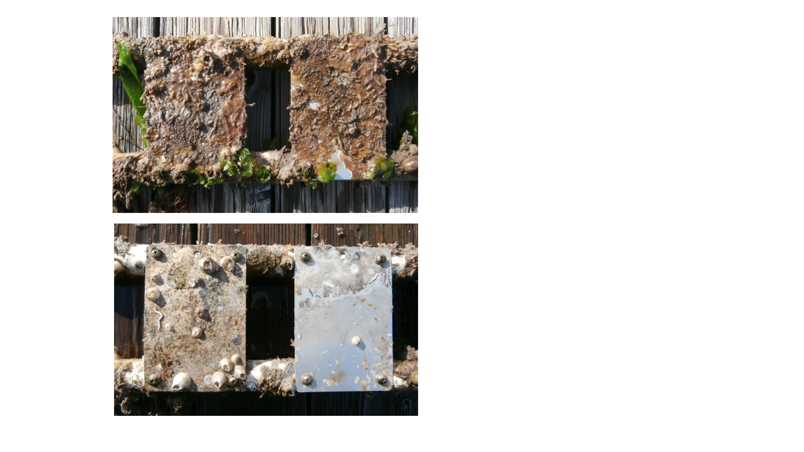
Figure 5 - The untreated aluminum control panel (left) and the ClearSignal panel (right) are shown before (top) and after (bottom) cleaning. The ClearSignal panel was easily cleaned, but the upper 1/3 of the panel exhibited coating separation.
Summary – The three copper-based treatments (copper tape, copper-based paint, and Cunifer 10) provided superior and equivalent protection. The primary distinction among these three is that the Cunifer 10 required no preparation or post-deployment treatment renewal. Both the ClearSignal and Aerokret treatments performed as advertised, providing easy cleaning, but without any apparent anti-foulant prevention. The plate coated with Desitin showed protection for the first two months, but after the third month became just as fouled as the control plates.

